On Windows run the command below to install AWS CLI

* Open powershell as administrator
* Run the command: choco install awscli –y
* Open git bash
* aws –version ……..to check your installed version
* go to your aws console in the browser, search for (IAM) Identity and Access Management, click on Add user.

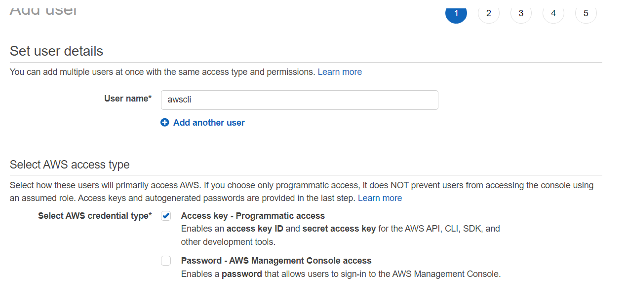

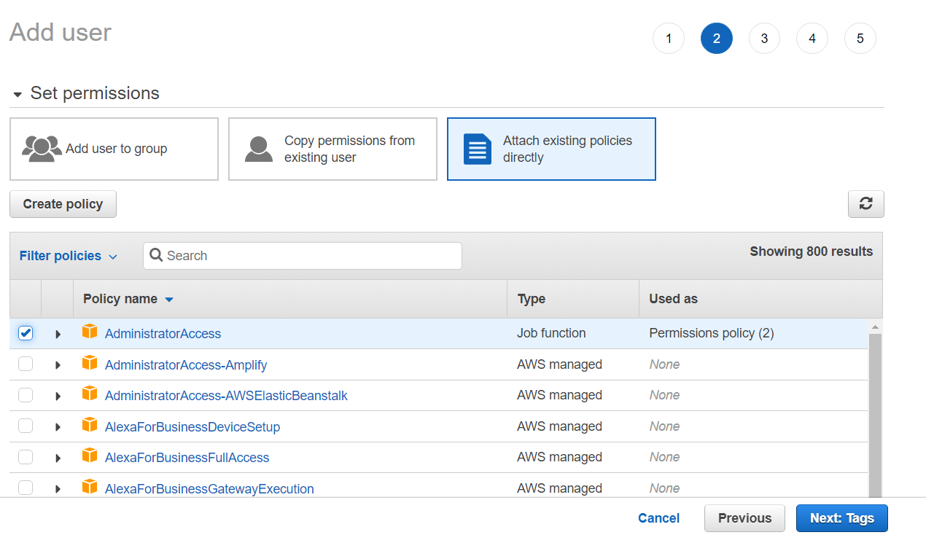

* Select only AdministratorAccess
* Click on Next (2c)
* Then click create user

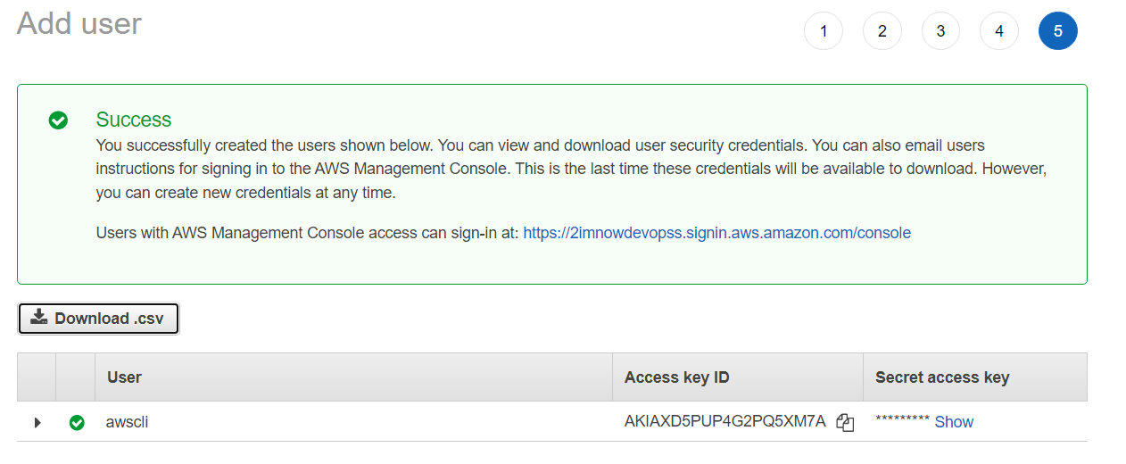

* Download and safe the .csv file or else you wouldn’t get it again
* Go to git bash run the following commands:
* aws configure
* copy the access key from the .csv file you downloaded paste
* copy the secret key from the .csv file you downloaded paste
* type the region in which you are logged in for your console
* output format ……. Json
* ls /.aws/config ……. To check your saved setting and know where it is saved
* cat /.aws/credentials ……. To check your saved login authentication details
* aws sts get-caller-identity …… to check details of who is accessing the aws
* aws ec2 describe-instances …….. full description of your instance

check:

(doc.amazon.com) ………….for awscli commands to configure

OR: check:

the pdf document: (AWS+Command+Line+Interface+Part+1)